TATA INSTITUTE
OF
SOCIAL SCIENCES


THE INTERNATIONAL FEDERATION OF RED CROSS AND RED CRESCENT SOCIETIES (IFRC)


ROBOTICS AND INFORMATION COMMUNICATION SYSTEMS ENGINEERING TECHNOLOGY from HAZARD FORECASTING TO DISASTER RESILIENCE

by
RAJA SHAHED
ITALIAN RED CROSS AND CIVIL DEFENSE

A TERM PAPER

submitted in partial fulfillment of the requirements for the course

ONLINE CERTIFICATE COURSE IN DISASTER MANAGEMENT

TATA INSTITUTE OF SOCIAL SCIENCES
Department of Social Science
School of Habitat Studies
Jamsetji Tata Centre for Disaster Management
Sion Trombay Road, Deonar, Mumbai: 400 088, India

In accordance with:
THE INTERNATIONAL FEDERATION OF RED CROSS
AND RED CRESCENT SOCIETIES ( IFRC )

2013 -2014
Approved by:
Professor Dr. Shibu MANIK

Copyright
RAJA SHAHED

15 Rue de sergent Bauchat
75012 Paris
FRANCE

© raja shahed
2013 – 2014
All rights reserved

ROBOTICS AND INFORMATION COMMUNICATION SYSTEMS ENGINEERING TECHNOLOGY from HAZARD FORECASTING TO DISASTER RESILIENCE

Raja SHAHED

Abstract

Robotics and Information Communication Systems Engineering Technology (RICSET), collaborative and or supplementary human performance are the future of the a to z and bull versus bull challenge of Disaster Management - from hazard forecasting to disaster resilience. This emerging, robust and promising technology will save not only victims of disasters, i.e. Human beings, animals and infrastructure but also will reduce the rescuer fatality in complex rescue operations. In a complex rescue operation - during the Nuclear plant explosion for example, where human rescuers are not able to advance because of harmful radiation - Rescue robots are the only messiahs to perform such ‘Mission Impossible’ interventions. Robots can be integrated in almost all domains of Disaster Management. Furthermore, the working scope, vulnerability and capacity of robots are beyond that of human rescuers. Rescue robots are capable of searching, evacuating, reconnaissance and mapping, removing or cleaning up debris, delivery of fundamental supplies and medical treatment of disaster victims. The progress of Information Communication Technology enables us to invent machines and electronic devices loaded with software to acquire geographical data more easily. Information Technology replaced the analogue Seismograph with the computer driven Seismograph which gives accurate Seismic activities data or information.

The goal of my study and research is to bring some domains of Disaster Management from traditional human guided Disaster Management to being carried out capably by Robotics and Information Communication Systems Engineering Technology to save our world, take away suffering and poverty, and bring peace and prosperity by performing technology driven, safe and wise Disaster Management.
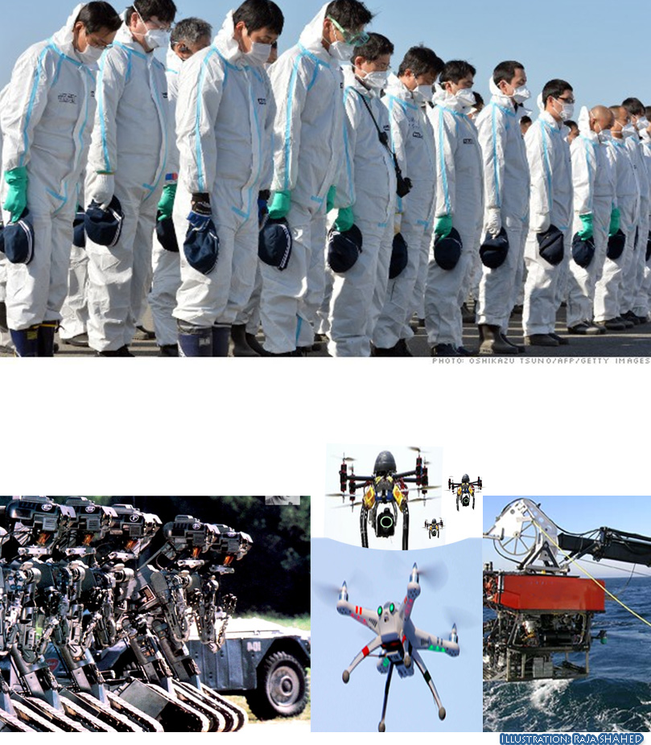

Keywords: Hazard, Disaster, Forecasting, Information Communication, Technology, ICT, Rescue robots , Artificial Intelligence, Automation, disaster technology, Complex, Management.

List of Acronyms

AUV | Autonomous underwater vehicles
CAC | Computer Augmented Communication
CBS | Central Bureau of Statistics
CRASAR | Center for robot assisted search and rescue
DARPA | Defense Advanced Research Projects Agency
DRR | Disaster Risk Reduction
EDM | Emergency and disaster management
GIT | Geospatial Information Technology
GIS | Geographical Information System
GPS | Global Positioning Systems
IPCC | Intergovernmental Panel for Climate Change
MIS | Management Information System
MT | Mobile Technology
RICSET | Robotics and Information Communication Systems Engineering Technology
ROV | Remote-operated Underwater Vehicle
RSS | Remote Sensing Systems
SDMS | Spatial Database Management Systems
UAV | Unmanned Aerial Vehicles
UGV | Unmanned Ground Vehicles
UNFCCC | United Nations Framework on Convention of Climate Change
UNOSAT | UNITAR Operational Satellite Applications Programme
UNITAR | United Nations Institute for Training and Research
UNDP | United Nations Development Programme
USV | Under Sea Vehicles
UNSPIDER | United Nation Platform for Space-based Information for Disaster  Management and Emergency Response

Glossary

Artificial Intelligence: | The ability of a computer or other machine to perform those activities that are normally thought to require intelligence.
Hazard | Dangerous event or situation that may lead to an emergency or disaster.
Disasters | A disaster is a sudden, calamitous event that seriously disrupts the functioning of a community or society and causes human, material, and economic or environmental losses that exceed the community’s or society’s ability to cope using its own resources.
Humanoid Robots | A robot resembling a human being
Robots | A machine that looks like a human being and performs various complex acts of a human being.
Snakebot | A snake like robot.
GIS | A computer application or system used to store, view, and analyze geographical information, especially maps.

Table of Contents
Copyright 3
Abstract 4
Glossary 7
Table of Contents 8
List of Figures 10
List of Tables 11
Acknowledgements 12
Dedication 13
Preface 14
Chapter 1 - Introduction 15
Chapter 2 - Robotics in Disaster Management 18
Chapter 3 - Rescue Robots 20
Chapter 4 - Ground robots 21
Chapter 5 - Aerial robots 23
Chapter 6 - Under water robots 24
Chapter 7 - Information and Communication System Engineering Technology ( ICT ) 25
Chapter 8 - Geo-Informatics Technology ( GIT ) 27
Chapter 9 - Geographical Information Systems (GIS) 28
Chapter 10 - Remote Sensing System (RSS) or Earth Observation (EO) 31
Chapter 11 - Global Positioning System ( GPS ) 32
Chapter 12 - Internet or web technology 33
Chapter 13 - Management Information System (MIS) 34
Chapter 14 - Smart phones and Short Message Service (SMS) 35
Chapter 15 - Summary 36
Evaluation 36
Future Work 36
Chapter 16 - References | Bibliography 37
Chapter 17 - Definitions and Differences 39

List of Figures
Figure 1.1 Two Rescue Robots are fixing the leakage of hazardous gas 17
Figure 2.1 A serpentine robot may substitute a human rescuer’s risky job 21
Figure 4.2 An aerial robot 23
Figure 4.2 A deep sea underwater AUV 24

List of Tables
Table 1.1 Complex and deadliest disasters and casualties since 526 AD 17
Table 2.1 Rescuers casualties 22

Acknowledgements
Mr. Chaya Ranjan Das, my favorite teacher from Elementary School. I still remember how he held my hand with a pencil and showed me how to write A B C D. Now this method is the process behind my thesis. Very special thanks to Prof. Dr. Barbara Russo of the University of Bolzano and other respected Professors.
Very special thanks to Mr. Umberto Tonero, Mr. Enzo Montesso, Mr. Roberto Antonini, Col. Roberto Baldassarelli of Italian Red Cross military corps and all good fellows of Italian Red Cross and Civil Defense ; Dr Peter Klotz of Forst Dienst Meran, Mr. Alexander Campestrini of Wasserrettung Südtirol, Dr. Pollinger of Wasserschutzbauten for the internship.
Very special people of Civil-Military Cooperation Centre Of Excellence (CCOE) of The Netherlands Col. Wiebe Baron, Capt. Stefanie Groothedde, Major Pieter Van Ingen, Capt. Wulf E. van Swetselaar, Major Andre Van de Ven, Capt. Roger Howard, Sgt. Major Coen Cornelissen, Captain Leen van der Wiel, Capt. Dick Kick of Dutch Marine; Capt. Pierre Blanchard of French Air Force; Major Jon Carlsen of Norwegian Army; Warrant Officer Marco Corstjens of Belgian Army; Lt. Christian Kliim Nydahl of Danish Royal Army; Lt. Col. Omso Hasic of Bosnian National Army; Major Maik Nuendel, Major Patrick Steinbach of Deutsche Bundeswehr; Lt. col. Vincenzo Bellanova, General Silvano Boriero, General Valter Cassar, Col. De Felici, Col. Fabiano Zinzone, Lt. Col. Riccardo Buonfine, Primo Maresciallo Paolo Fabro, Maresciallo Antonio Colia, Maresciallo Alberto Politano, Lt. Alessandro Ante of Italian Army and all allies of Multinational Civil Military Cooperation center of Motta di livenza, Italy.
Two professors of TATA INSTITUTE OF SOCIAL SCIENCES, without their help I could not come so far – My very heartfelt thanks to them for their help and patience over the year: Ms. Niti Mishra and Ms. Parama Bhattacharyya and sincere thanks to the ONLINE Team.

I am very grateful to Prof. Dr. Shibu MANIK who is not only a professor but also a very friend of mine: for providing his field expertise and guidance as my honorable advisor.

Finally TATA INSTITUTE OF SOCIAL SCIENCES and THE NTERNATIONAL FEDERATION OF RED CROSS AND RED CRESCENT SOCIETIES (IFRC) for organizing such an outstanding course for rescuing humans in grave danger.

Dedication

My Dissertation work is dedicated to my family, relatives, teachers, instructors and to my friends. A sublime feeling of gratitude to my loving parents - Mr. Sadeque RAJA and the late Mrs. Taherun Nessa whose words of encouragement, effort and future dreams reinforced my studying Disaster Management. My beloved sister Rubi.

Franz, Margherita, Enzo Montesso, Andy, Philipp, Nadja, Karin, Mike and Kate for being always good friends.

Ms. Paola Mezeyova, Mlle. Claire Landrèat of Paris, Frau Christine Nothdurfter of Taisten.

My work is also dedicated to my boss, flight instructor and my best friend Herr Dr. Joachim Ladurner.

Preface
Disasters are the common challenge of almost every community. Disasters disrupt our habitats, and kill or injure our loved ones. Some of them are unbeatable and faceless monsters. Without using modern technology it is almost impossible to even predict them. Nevertheless disasters, particularly natural disasters, cannot be eliminated but losses and destruction can be reduced by wise disaster management commenced with precise and reliable mitigation. As technologies are developing - protection against disasters are also developing simultaneously. Thanks to ICT and Robotics we are almost able to face them off and even avoid their devastation. Internet or web technology brings us real time and effective hazard forecasting, related early warning and preparedness communications through ICT.

My work is based on my nearly two decades long Information Communication Technology (ICT) programming, networking, automation, regular rescue and Disaster management knowledge acquired at the Italian Red Cross (Croce Rossa Italiana), French Red Cross (Croix Rouge Française), Italian National Civil Defense (Protezione Civile Nazionale) and the North Atlantic Treaty Organization (NATO). I’m trying to amalgamate the further development of existing and functioning technologies, empirical evidences with hypothetical or futuristic technological probability to reach the paramount technique of Disaster management.

Robots are showing incredible and promising performance by doing tasks as a slave or an autonomous master. The simultaneous evaluation and expansion of robotics and ICT hint us a new paradigm of robust and powerful technology that enables us to reach the goal of utmost precision, satisfactory and effectiveness in disaster management

Introduction
Disasters are a common problem of our daily life - particularly in developing countries. Each time you blink your eyes – there are disasters happening somewhere in the world, either natural or human-made. Disasters deteriorate our achieving of Millennium Development Goal, contributing to permanent suffering and leading to poverty. Natural Disasters like Earthquake, Volcanoes, Flood, Fire, Tornado, Tsunami, Nuclear Plant Meltdowns, Terrorist attacks, War are devastating our dream of living in peace and we are increasingly suffering from their effects.
Climate change, deforestation, illegal mining, unplanned industrialization, population growth, war, poorly planned nuclear power plants and their consequences contribute to natural disasters like earthquake, volcanoes, flood, fire, tornado, tsunami, nuclear plant explosions, terrorist attacks, war etc. The aftermath of these disasters is devastating. Some disasters are so devastating that in a few hours they may destroy a civilization and development that were achieved over many years, even centuries, affect lives of hundreds of thousands of people, animals, crops, houses and infrastructure such as schools, hospitals, community centers, religious structures, factories, industries and properties. Some disasters are so complex and dreadful that rescuers cannot even approach them.
In 1984, a leak of methyl isocyanate gas at a Union Carbide plant in Bhopal, India caused a casualty of 8,000 lives within two weeks and another more than 8,000 casualty from gas-related diseases and left 558,125 injuries including 38,478 temporary partial injuries and approximately 3,900 severely and permanently disabilitating injuries.
On April 26th, 1986, a nuclear power plant in Chernobyl, Ukraine failed violently and cost the lives of 31 people during the accident and the released radiation has caused an additional 4,000 cancer deaths.
On March 11th, 2011, Catastrophic failure at the Fukushima Daiichi Nuclear Power Plant cost the lives of 18,500 people due to the earthquake and tsunami and approximately 1,600 deaths were related to the evacuation conditions.
In such devastating and complex mishaps human rescuers can do nothing but accept the aftermath because of the radiation or suffocating toxicant gas, heat and other obstacles but advanced rescue robots can be deployed to such jobs such as access to the contaminated areas to perform improved maintenance, emergency evacuation, quarantine, mass decontamination, cleaning debris and resilience or rebuilding later. Robots are able to help measuring ground or underwater structural damage and go where human responders or divers cannot go because of the debris or the depth of water. Robots can be deployed together with ICT supported devices to forecast a hazard before it turns to disaster, perceptions of risk to those exposed, declaring and disseminating early warning system and taking other necessary measures. The more reliable and earlier the prediction - the lower the destruction is. Only ICT can make reliable predictions by using ad hoc system tools and devices.
The aggravating factors like climate change, unplanned-urbanization, terrorism as well as the threat of pandemics will result in increased frequency, complexity and severity of disasters. In a perilous Search and Rescue (SAR) missions rescue robots are better than human rescuers as ‘damage of a robot is not loss of a life’. During the nuclear meltdown humans would have no chance of survival but the mechanized rescue robot team can be ready for action to bring the situation under control. Aerial robots can help ground rescuers by providing them with immediate pictures of the loss and structural damage from sites where situations are potentially unsafe for human rescue workers.

In this sense – Robots can rescue not only disaster victims but can also spare the lives of human rescuers in complex rescue operation.

The heart and soul of technologies in disaster management is Information communication technology or ICT. ICT software or tools are able to acquire weather data information factors for reliable weather forecasting and disseminate them as daily weather forecasting or warning to our smart phones or send us via E-Mail. Information technology plays a vital role in all four phases of disaster regardless pre, during and post disaster. Nowadays it is out of the question managing disaster without ICT. As a matter of fact, ICT makes Disaster management routine and acts as the right hand of disaster rescuers or managers to cope with disasters.

Figure 1.1 Two Rescue Robots are fixing the leakage of hazardous gas
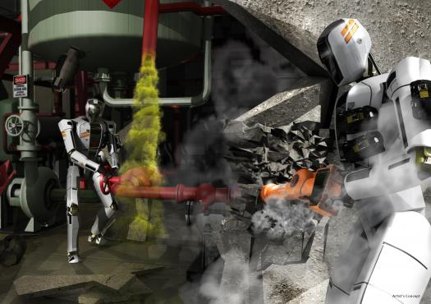
Image courtesy of : DARPA

Table 1.1 Complex and deadliest disasters and casualties since 526 AD
SN | Disasters | Human casualties | Year | Country
1 | China floods | 1,000,000–4,000,000 | 1931 | China
2 | Yellow river flood | 900,000–2,000,000 | 1887 | China
3 | Shaanxi earthquake | 830,000 | 1556 | China
4 | Tangshan earthquake | 242,000–779,000 | 1976 | China
5 | Bhola cyclone | 500,000–1,000,000 | 1970 | Bangladesh
6 | India cyclone | 300,000 | 1839 | India
7 | Calcutta cyclone | 300,000 | 1737 | India
8 | Haiyuan earthquake | 273,400 | 1920 | China
9 | Antioch earthquake | 250,000–300,000 | 526 | Turkey

Robotics in Disaster Management
According to The American Heritage® Dictionary of the English Language – Robotics is the science or study of the technology associated with the design, fabrication, theory, and application of robots. It is an interdisciplinary field of study and subset of Information technology or Computer science, Electronics and Mechanical engineering. At devastating and complex disasters like Chernobyl and Fukushima Nuclear Plant disasters human would have no chance of survival and only mechanized rescue robots could be deployed to save victims and bring the situation under control. In January 1995, it was the Great Hanshin-Awaji earthquake that hit Kobe City of Japan and caused more than 6,500 casualties, with damages exceeding $1 billion dollars which induced the idea of deploying rescue robots and the development of robotics, in particular rescue robotics. The terrorist attack in New York known as 9/11 was the disaster theater where real rescue robots were implemented. In 9/11 disaster robots were deployed searching for victims and paths through the rubble, inspecting structures, and looking for hazardous materials and so on.

Many countries and companies are developing robotics technology to build intelligent and efficient robots to cope with earthquake, floods, tsunami, terrorism, mine disasters etc. Modern robots are equipped with intelligent sensors, information equipment and human interfaces that support emergency response activities such as urban search and rescue, information gathering by using their built in sensors and camera to enable to and fro transaction of communications. The development of robotics technology, in particular rescue robotics according to their capacity, hardware and Software integration so far:
- Information Infrastructure System Mission Unit (IIS): Distributed sensors, RFID tags, integration protocol, database, and mapping;
- In-Rubbles Robot System Mission Unit (IRS): Serpentine robots, advanced rescue tools, advanced search cams, advanced fiber scopes, sensors, and human interface;
- On-Rubbles Robot System Mission Unit (ORS): Tracked vehicles, jumping robot, ultra-wide-band radar, semi-autonomous movement, ad-hoc communications.

Typical robotics technologies include teleoperated robots for victim search in hazardous disaster area and wise sensors for gathering disaster information to support human or robot and ICT aided decision making. Some robots are able to navigate autonomously with human direction to establish goals for exploration. In the field of robotics noteworthy technologies are Human Detection System (HDS), Simultaneous Localization and Mapping (SLAM), Logistic and supply chain management (SCM) capacity.

Rescue Robots
In complex disasters - dangerous rescue tasks such as handling toxic chemicals, radiation, extreme heat or fire in gaseous, poisonous, under rubble, deep water surroundings are quite inconceivable for human rescuers. The deployment of rescue robots are intended to substitute humans in risky tasks, perform jobs that cannot be performed by a human, enable rapid and sure task execution without fail. Another quality of robots is also their capability to transact data between the vehicle and the mission monitoring computer. If a human is exposed to radiation they may get radiation sickness and cancer. According to their functioning capacity, whether functioning totally autonomous or with human supervision - robots can be classified as a master or a slave. They can be legged or wheeled, humanoid or mechanized. Robots are used to assess the structural inspection after disasters. Security department uses robots to find explosive or hazardous devices and incapacitate or neutralize them. It is very necessary to identify the disaster location, disaster aftermath, the situation of victims in timely or as soon as possible so that rescue team can involve themselves for taking further measures but very often human rescuers are unable to advance. Snakebots, insect, creepy crawly-like, tiny, lean and thin robots can be very useful for assessing the extent of damage under the rubble or debris.

Ground robots
Unmanned Ground Vehicles (UGV) or Ground robots are developed to have sophisticated characteristics such as Rapid Deployment, allow reliable remote operation from a safe distance, have the ability to move quickly though complex environments, have enough protection to avoid being damaged while performing its duties, field-serviceable and be available in varying sizes and adaptable to varying environments like a lean and thin serpentine robot. One of the intelligent uses of ground robots is to perform search and rescue in structural collapses- crawling underground in building collapses and mine disasters that is very dangerous for human rescuers. Bomb Detection, Unmanned Logistics Vehicles, Nuclear Response Robots, First Responder Robots are very common ground robots.

Figure 2.1 A serpentine robot may substitute a human rescuer’s risky job
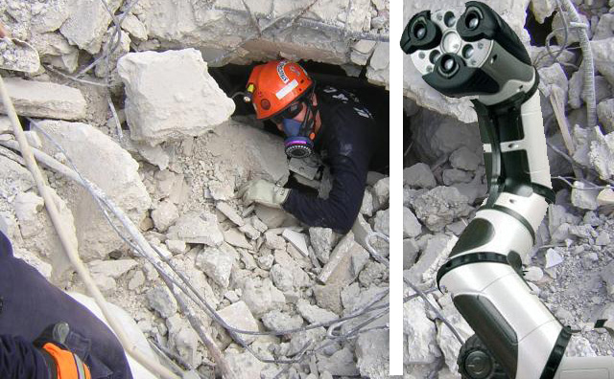

Table 2.1 Rescuers casualty
SN | Events | Countries | Casualties | Year
1 | Mexico City earthquake | Mexico | 135 | 1985
2 | World Trade Center terror attack | USA | 402 | 2001
3 | Fukushima Nuclear meltdown | Japan | 227 | 2011

Aerial robots
Aerial robots or UAVs are permanent team members and play significant roles in any phase of disaster management - pre, during and post disaster. They are very efficient doing rescue, transport, SAR, distribution of fundamental need and providing up-to-date aerial images of the devastated ground.
It is very crucial capturing and sending an overview aerial image of a disaster affected area in order to inform first responders in disaster management. The overview image can be images or videos of the area of interest but real time and up-to-date. From the overview aerial image first responders can assess the magnitude of the destruction and plan the measure to be taken. The modern UAVs are able to acquire real-time sensing data, collect and deliver by flying over an area of interest by using their sensors, GIS and GPS receiver.
Aerial Robot System Mission Unit (ARS) includes Drones, Intelligent helicopters, balloons, image processing, human interface and so on.

Figure 5.1 An aerial robot
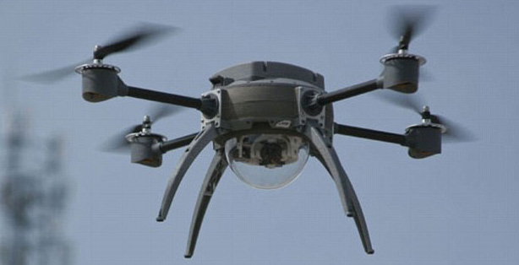
Image courtesy of: Aeryon lab.

Under water robots
Under water robots or AUVs (autonomous underwater vehicles) are engineered to offer excellent swim and float capability preferably with amphibian characteristics. They are able to perform better under water search and rescue, collect and transmit under water structural damages, cleanup of debris, rescue vehicles, materials. Human under water rescue divers have limitations of depth, degree of extreme cold water, darkness and dirty or turbid water that underwater robots do not.

Figure 6.1 A deep sea underwater AUV
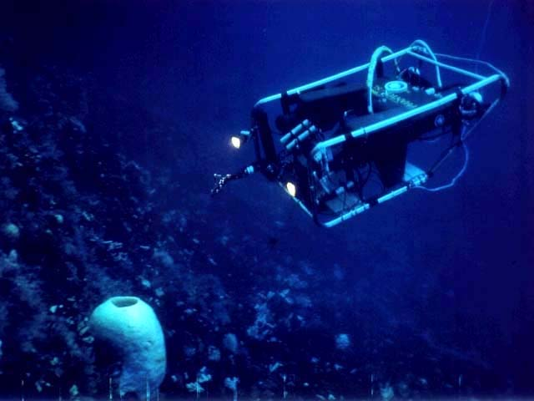

Information and Communication System Engineering Technology ( ICT )
Advanced disaster management technology could provide a critical support system for disaster management authorities at times of disaster-related crises. Geographical Information Systems (GIS), Global Positioning Systems (GPS) and Remote Sensing Technologies play a very important role in disaster management. An Indian scholar labelled GIS as the foundation for Emergency Management. They enable the mitigation or countermeasures against possible disaster. Robots or automated machines and vehicles are being developed very rapidly for deployment in complex disasters like Nuclear plant explosion, – fusion human capabilities for rescue are very limited but Robots can substitute human Rescuers.
- Remote sensing;
- Geographical Information System (GIS);
  - Global Positioning System (GPS);
  - Satellite navigation system;
  - Satellite communication;
  - Cellular phones;
  - Internet, e-mail; and
  - Special software packages, on-line management databases, disaster information networks.
Disaster management professionals depend on ICSTs for critical solutions during almost all phases of disaster management. These include:

• early disaster warning, dissemination, and evacuation; disaster information, quick
processing and analysis;
• database construction;
• information integration and analysis;
• disaster mapping and scenario simulation;
• hazard assessment and monitoring;
• disaster trend forecasting;
• disaster characteristic factor monitoring;
• vulnerability assessment;
• emergency response decision support;
• planning of disaster response, reduction, and relief ;
• logistics preparation for disaster relief;
• needs assessment for disaster recovery and reconstruction;
• risk investigation and assessment;
• disaster loss assessment;
• monitoring of recovery and reconstruction; and
• rehabilitation.

Geo-Informatics Technology ( GIT )
Geo-informatics is the science and technology of gathering, analyzing, interpreting and distributing geographic information. Geo-informatics facilitates collaborative multidisciplinary research and increases our capacity to understand the earth as a dynamic and complex system in which natural resources can be managed in a sustainable way. Remote Sensing Techniques (RS), Geographic Information Systems (GIS) and modeling, and Global Positioning Systems (GPS) are all a part of Geo-informatics.

Geographical Information Systems (GIS)
Geographic Information System (GIS) is an information technology based system, combined with hardware and software program or tool used to retrieve or store Geographic information. GIS is also able to manipulate gathered data. The further development and use of remote sensing and Geographical Information System GIS have come a long way and both together become an integral and reliable tool in disaster management.

Geographic Information Systems (GIS) help to integrate, store, edit, analyze, share, and display geo-referenced information. It provides the framework for planners and disaster managers to view spatial data by way of computer based maps. GIS and Remote Sensing System and application can also be used to monitor, predict and model hurricanes, epidemics, chemical cloud dispersion, oil spills, forest reserve degradation, drought, earthquake, floods, tsunami, wildfires, volcanic activities etc.

- Mitigation/ Prevention –
- Disaster risk identification and prevention priority assessment
- Disaster plan management
- Plan exercise and visualization

- Preparedness –
- Disaster monitoring & early warning
- Disaster simulation
- Disaster Response –
- Disaster response and emergency rescue
- Command and dispatch
- Disaster information display and real‐time
- Publishing
- Recovery –
- Disaster assessment
- Post‐disaster reconstruction planning

Disaster events, such as wildfires, tsunami, floods, earthquakes, hurricanes, epidemics, chemical cloud dispersion, and oil spills, can be modeled and displayed in GIS. Emergency management personnel can use modeling for training, for actual tactical deployment during a disaster, or to analyze the consequences of a possible disaster. The use of this technology takes emergency management planning information off the shelf for utilization by response personnel in real-world operations

GIS is also able to provide doing the following tasks:
- To create hazard inventory maps
- Locate critical facilities
- Create and manage associated database
- Vulnerability assessment

Emergency management programs are developed and implemented through the analysis of information. The majority of information is spatial and can be mapped. Once information is mapped and data is linked to the map, emergency management planning can begin. Once life, property, and environmental values are combined with hazards, emergency management personnel can begin to formulate mitigation, preparedness, response, and recovery program needs. Historically, emergency management programs are planned, implemented, and modified based on volume of business or reaction to emergencies as they occur.
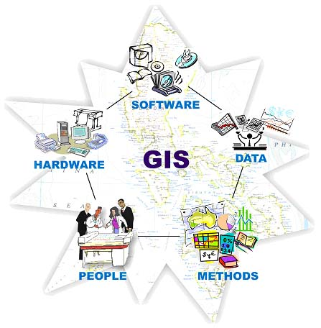

Some GIS tools can store, process information extracted from satellite images acquired by using Remote sensing Technology and store them in a database. Accurate and timely information is a critical part of any successful emergency management program. A geographic information system (GIS) can provide that sort of information.

Remote Sensing System (RSS) or Earth Observation (EO)
Remote sensing is the technology used to acquire information about material objects, area or phenomenon, without coming into physical contact with them and by using some mean of transferring information through space. Remote sensing is a process used to retrieve or acquire spatial data, geographic or environmental from space borne or air borne sensors or sensor networks. It is also used in the field of astronomical, astrophysical and geophysical research for the monitoring of earthquakes and other phenomena. GIS and Remote Sensing together help forecasting disasters.
• Quickly assessing severity and impact of damage due to flooding, earthquakes, and other disasters;
• Planning efficient escape routes from coastal areas during hurricane season;
• Charting quickest routes for ambulances to reach victims;
• Locating places for shelter for victims or refugees;
. Calculating population density in disaster-prone areas;
• Rapidly identifying hardest-hit disaster areas in order to provide early warning of
potential disasters;
• Pre-disaster assessments to facilitate planning for timely evacuation and recovery
operations during a crisis;
• Monitoring reconstruction or rehabilitation after a major disaster; and
• Developing, maintaining or updating accurate base maps.

Global Positioning System ( GPS )
Using modern technology in disaster mitigation and management is de facto and an absolute must for monitoring natural disasters like earthquakes, floods, cyclones, volcanic eruptions, landslides, avalanches etc. GPS is being used for numerous navigational and positioning applications, including navigation on land, in the air and on the sea, determining the precise coordinates of important geographical features as an essential input to mapping, precise cadastral surveys, vehicle guidance, earthquake and landslide monitoring. GIS and GPS systems play a significant role in human development, natural resource management, disaster monitoring, science, engineering, and technology.
For effective rescue and rehabilitation operations it is important that the latest digital map data on the largest possible scale, and GPS, GIS integrated positioning systems are made available to the disaster management teams,. The effective monitoring and management of natural calamities requires the most recent terrain information, and quick updating of the digital maps / GIS of the affected area on a real–time basis. For this purpose, aerial photographs and satellite imagery of the area, when integrated with the digital maps GIS, can yield the best results. For controlling the scale and other errors in the imagery, ground survey control is absolutely essential. The GPS technique can be used for this purpose, to yield very accurate results in an efficient and economic way. The GPS receivers on-board the camera can provide the accurate co-ordinates in real-time basis, and GPS surveys on the ground can establish an accurate GPS ground control network.
By integrating GPS and Remote sensing information it is possible to enrich the GIS system.

Internet or web technology
After the ensuing disasters tracing missing persons, coordinating donor groups, distribution of relief, recording the location of temporary groups or shelter are most essential tasks. Access to communication technologies at the local level is vital to successful disaster recovery. Internet based hosted software or Social media help provide live updates on the ground conditions and also helped to quickly generate global donations for relief-related work, information exchange with other relief agencies during the disaster.
Mobile phones are the primary source of communication for family and friends. The Internet, and Internet-based social media, is an important source for telling the world about a disaster, asking for donations, relief, shelter for homeless people, disseminating ‘lessons learnt’ etc. Communication is imperative after a disaster in order to coordinate the relief effort effectively.
The role Internet and email can play in disaster warning depends entirely on their penetration within a community. These media can play a prominent role in a developed country where nearly half of all homes and almost all offices have Internet connections. In many developing countries, however, less than five percent of the population uses the Internet and even those who are users, do not use it on a regular basis. Internet based hosted software or Social media help provide live updates on the ground conditions and also helped to quickly generate global donations for relief-related work, information exchange with other relief agencies during the disaster.

Some useful and important web sites are:
- Reliefweb
- Alertnet
- Preventionweb
- EM-DAT disaster Database
- Pacific Disaster Center

Management Information System (MIS)

The use of Management Information System (MIS) in disaster management does not only help in co-ordination of the post disaster but also in spreading awareness, bringing in donations and in making the system transparent. Very often the process of relief distribution is problematic in the absence of an efficient system of information dissemination. Proper and timely use of ICT enables mobilizing and distributing relief materials and make relief effective in the disaster affected areas. The information gap is the source of wider problems in effective logistics, relief and support works.

Online software plays a vital role in communicating with donor organizations with detailed information. Disaster relief plans can be published using social media including reports, illustration and images and videos of the devastation of disasters information, the magnitude of the human suffering and loss of property and achieve the credence of emergency relief organizations.
Tablet PCs, laptops can be used to connect to the internet and exchange information with other relief agencies if the Internet service providers are still functional. Nowadays many cell phones or smart phones are able to provide the capability of browsing internet or using stand-alone software. Software-based technologies are being developed around the world to improve post-disaster co-ordination. Websites such as Reliefweb, Reuters-Alertnet and Glide-Number are among the most acclaimed globally. By using Sahana open source software we can do the following:
Gathering a missing persons’ information registry, an organization registry to know and co-ordinate who’s doing what and where, a camps registry to input information related to relief camps, a request management system wherein requests and immediate aids can be matched with organizations ready meet these needs, an inventory management system.

Smart phones and Short Message Service (SMS)
Short message service (SMS) is a life saving warning system in many developing countries where modern technology or even stable electricity supply is not available. In many developing countries people suffer from lack of electricity, television and Internet but some of them possess a cellular phone. By exchanging reliable hazard or disaster warning through cellular phones a community can perform an effective primary risk reduction by doing disaster preparedness, evacuation, etc. Smart phones are suitable for browsing internet, receiving email, navigating or calculating a route, not only making phone calls or sending/receiving SMS. That is why Mobile networks should be robust. Earth observation satellites could also be used in emergency situations where on-the-ground resources are often not available or destroyed. Satellites can provide data rapidly when there are disasters like earthquakes or floods that often prevent assessment by ground or aerial services. They also provide accurate global coverage and operability, no matter what the weather or ground conditions. Wireless communication plays an important role in post-disaster relief activities co-ordination as well. Mobile phones and mobile service save lives during the disasters by improving the communication system. As the GSM, UMTS and other mobile networks are virtual-networks - no disaster can destroy them unless they are hit in their physical providing centers. So like Radio a mobile phone can also be used for ICT in earthquake affected area after the destructions of the communication system.

Summary
In order to reduce human causalities and injuries, including human rescuers, and economic losses – it is very crucial to respond in a timely and effective manner by using modern technology driven Disaster Management. Evolution of Information communication technology, robotics and availability of hardware is helpful for rapid technological expansion to fight against disasters. Robotics and ICT are able to perform such activities.

Evaluation
In this paper I showed the capacity and the future expectation from robotics being deployed in disaster management in order to save human rescuer casualties. Furthermore I demonstrated that using robots, particularly in a complex disaster theater, has many benefits. Using rescue robots in some disaster domains are still under way but it is promising. Therefore, I feel strong and confident on my ground and subject area “ROBOTICS AND INFORMATION COMMUNICATION SYSTEMS ENGINEERING TECHnoLOGY from HAZARD FORECASTING TO DISASTER RESILIENCE” are the future of the disaster management.

Future Work
Expansion of the present ‘Term Paper’ by developing the details of specific robots and ICT. My future agenda is research on decombustible and heat-proof robots and, of course, more independent robots. I would like to present my project to ask international organizations like United Nations, European Union, NATO (EADRCC), AU to provide a disaster robots department for building, researching and managing a worldwide network to provide disaster robots in times of need.

References | Bibliography

D. Greer, P.J. Mc Kerrow, and J. Abrantes, 2002. 'Robots in Urban Search and Rescue Operations', Proceedings ACRA'2002, Aukland, November, pp 25-30
Lillesand. T.M. and Kiefer, R.W. (1987). Remote Sensing and Image Interpretation. John Wiley & Sons.
Ramachandran, Prof. S., (1998). Vice Chancellor: University of Madras. Application of Remote Sensing and GIS. Page 540 - 558
H. Asama, Y. Hada, K. Kawabata, I. Noda, O. Takizawa, J. Meguro, K. Ishikawa, T. Hashizume, T. Ohga, K. Takita, M. Hatayama, F. Matsuno, S. Todokoro: "Information Infrastructure for Rescue Systems", Workshop on Rescue Robotics - DDT Project on Urban Search and Rescue, 2007 IEEE/RSJ Intl Conference on Intelligent Robots and Systems, pp. 45-56, San Diego, USA, Oct. 2007.
Center for Robot-Assisted Search and Rescue - Department of Computer Science and Engineering Texas A&M Engineering
Satoshi Tadokoro, Fumitoshi Matsuno, Hajime Asama, Masahiko Onosato, Koichi Osuka, Tomoharu Doi, Hiroaki Nakanishi, Itsuki Noda et al: (2007) " DDT Project on Urban Search and Rescue, IEEE/RSJ07 Intl Conference on Intelligent Robots and Systems, pp. 1-22, San Diego, USA, October.
R. R. Rao, J. Eisenberg, and T. Schmitt. Improving Disaster Management: The Role of IT (Information Technology) in Mitigation, Preparedness, Response, and Recovery. National Academies Press, Washington, USA, 2007
M. Berioli, N. Courville, and M. Werner. Integrating Satellite and Terrestrial Technologies for Emergency Communications (2007) The WISECOM Project. In Proceedings of the Int. Conf. on Heterogeneous Networking for Quality, Reliability, Security and Robustness, August.
Murphy R. (2004): Activities of the Rescue Robots at the World Trade Center from 11–21 September 2001. IEEE Robotics & Automation Magazine
The Sphere Project: Humanitarian Charter and Minimum Standards in Disaster Response http://www.sphereproject.org
Prof Madhav N Kulkarni: Geodesy & Remote Sensing Division, Department of Civil Engineering, Indian Institute of Technology, Bombay, kulkarni@iitb.ac.in

Definitions and Differences
Natural hazards: Natural hazards are naturally occurring physical phenomena caused either by rapid or slow onset events which can be geophysical (earthquakes, landslides, tsunamis and volcanic activity), hydrological (avalanches and floods), climatological (extreme temperatures, drought and wildfires), meteorological (cyclones and storms/wave surges) or biological (disease epidemics and insect/animal plagues).

Technological or human-made hazards: Technological or human-made hazards (complex emergencies/conflicts, famine, displaced populations, industrial accidents and transport accidents) are events that are caused by humans and occur in or close to human settlements. This can include environmental degradation, pollution and accidents. Technological or man-made hazards (complex emergencies/conflicts, famine, displaced populations, industrial accidents and transport accidents)

Vulnerability: A condition wherein human settlements, buildings, agriculture, or human health are exposed to a disaster by virtue of their construction or proximity to hazardous terrain.

Mitigation: Measures put in place to minimize the results from a disaster. Examples: building codes and zoning; vulnerability analyses; public education. Mitigation refers to all actions taken before a disaster to reduce its impacts, including preparedness and long-term risk reduction measures.

Preparedness: Planning how to respond. Examples: preparedness plans; emergency exercises/training; warning systems.

Response: Initial actions taken as the event takes place. It involves efforts to minimize the hazards created by a disaster. Examples: evacuation; search and rescue; emergency relief.

Recovery: Returning the community to normal. Ideally, the affected area should be put in a condition equal to or better than it was before the disaster took place. Examples: temporary housing; grants; medical care.

Blackbody radiation: Refers to an object or system which absorbs all of the electromagnetic radiation that falls onto it; the object or system then re-radiates this energy. The energy that is re-radiated is characteristic of the radiating system from which it is emitted, not its original source.

Electro magnetic spectrum: The electromagnetic (EM) spectrum is the range of all possible electromagnetic radiation.

Electromagnetic wave: Method of travel for radiant energy, so called because radiant energy has both magnetic and electrical properties.

Infrared radiation: Electromagnetic radiation whose wavelengths lie in the range from 0.75 micrometer to 1000 micrometers.

Infrared sensors: This is an electronic device which measures infrared light radiating from objects in its field of view.

LandSat: A series of satellites that produce images of the earth.

Microwave radiation: Electromagnetic radiation composed of photons carrying less energy than infrared photons but more energy than radio photons.

Radiation: Energy that is radiated or transmitted in the form of rays or waves or particles. Sensor: An electronic device used to measure a physical quantity such as temperature, pressure or loudness and convert it into an electronic signal of some kind.

Wavelength: The distance between identical points in the adjacent cycles of a waveform signal propagated in space or along a wire.
Internal Disturbances: Internal disturbances are those events or activities planned by a group or individual to intentionally cause disruption. This includes riots, demonstrations, large-scale prison breaks, and violent strikes.

