Multinational corporations and civil society

Introduction
In the realm of international relations, the influence of multinational corporations and civil society cannot be overstated. While states and international organizations often dominate the discourse, these two actors play pivotal roles in shaping global policies, economies, and social structures. This lesson aims to delve into the complexities of how multinational corporations and civil society interact within the framework of international relations.

Learning Objectives
- Understand the role of multinational corporations in international relations.
- Explore the influence of civil society, including NGOs and grassroots movements, in shaping international policies.
- Examine case studies to understand the real-world implications.

Diagram: Multinational Corporations and Civil Society in International Relations

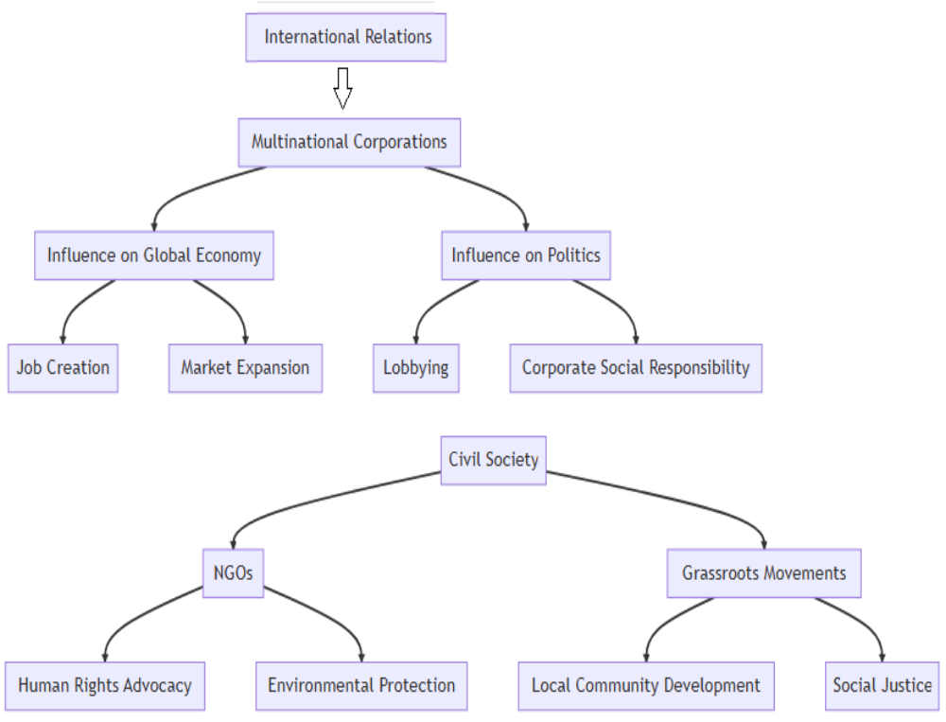

Explanation of Diagram
The diagram illustrates the multifaceted roles of multinational corporations and civil society in international relations.
- Multinational Corporations: These entities have a significant influence on both the global economy and politics.
  - Influence on Global Economy: Through job creation and market expansion.
  - Influence on Politics: Through lobbying and corporate social responsibility initiatives.
- Civil Society: Comprises NGOs and grassroots movements.
  - NGOs: Involved in human rights advocacy and environmental protection.
  - Grassroots Movements: Focus on local community development and social justice.

Case Studies
- Apple Inc. and Tax Policies: Apple Inc., a multinational corporation, has been in the limelight for its tax avoidance strategies, affecting state revenues globally.
- Greenpeace and Environmental Policies: The NGO Greenpeace has been instrumental in pushing for stringent environmental policies at international forums.
- #MeToo Movement: A grassroots movement that started in the United States but had global implications for gender equality and sexual harassment policies.

Practical Exercise
- Role Play: Assume the roles of executives from a multinational corporation and members of an NGO. Engage in a mock negotiation on a policy issue.

Self-Assessment

Essay: Discuss the ethical responsibilities of NGOs in shaping international

Definition of Lobbying
Lobbying refers to an activity that involves influencing the actions and decisions of individuals, groups, or organizations. It is most common in government contexts in which an individual or group tries to influence the government's actions, typically in written or verbal form.

What are Lobbyists and Lobby Groups?
A lobbyist is an individual who influences others on behalf of third parties, often for compensation. They are commonly lawyers, former politicians, or policy experts. Meanwhile, lobby groups are groups of people working collectively to influence decision-makers. These groups, which often receive compensation, include special interest groups, corporations, and trade associations.

Types and Methods of Lobbying
- Legislative lobbying involves corporations or groups represented by lobbyists to meet elected officials. The goal is to discuss the client's position and interests.
- Regulatory advocacy lobbying focuses on influencing the regulatory process, created by government agencies outside the legislative process, through campaigns and public relations.
- Budget advocacy lobbying includes efforts to shape public budgets and funding allocations. This often involves budget data to regulate policies and outcomes.

Example of Lobbying
A good example of lobbying in a school setup is when parents of students lobbied against the placement of soda vending machines in schools. They communicated with the school board, superintendent, and public officials. The officials compromised by turning off vending machines during school hours.

Ethical Considerations and Regulations
The Honest Leadership and Open Government Act of 2007 regulates monetary contributions to election campaigns and travel on private jets. States enforce compensation thresholds, requiring lobbyists to register to ensure transparency. Also, lobbyists are prohibited from paying politicians for votes.

Which is an example of lobbying?
An example of lobbying is a special interest group that hires a lobbying organization to influence an elected official on a particular policy or law, such as with a pro-climate change group that hires a lobbyist to influence elected officials to create legislation addressing rising temperatures in a specific geographic location.

What is a lobbyist in simple terms?
A lobbyist is someone who communicates with someone else or a group to influence them. It is typically done on behalf of another individual or group in exchange for payment.

What are the 3 main types of lobbying?
The three main types of lobbying are legislative lobbying, regulatory advocacy lobbying, and budget advocacy lobbying. Each type differs according to the types of policies and agencies they seek to influence.

What is lobbying in simple terms?
Lobbying is when an individual or group seeks to influence another individual or group to achieve a desired outcome. This is often done on behalf of a third party who has hired the lobbyist.

Is lobbying illegal?
Lobbying is not illegal. However, there are ethical concerns and legislation according to each state and by the federal government with regard to what practices are considered legal or illegal.
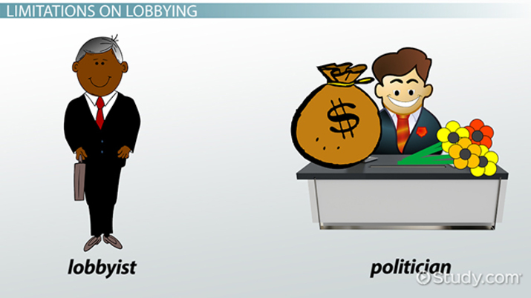

Summary
Understanding the roles of multinational corporations and civil society is crucial for a holistic view of international relations. These actors have the power to shape policies, influence states, and bring about social change.

